High Performance
Paper

Japan is top manufacturer of high performance paper like friction materials for automobile break

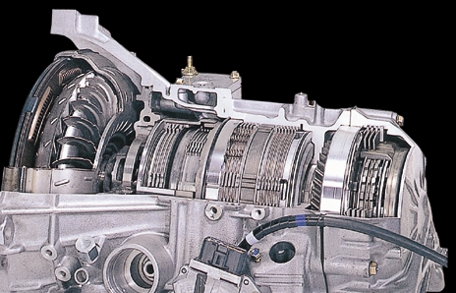
High performance paper is widely used in Auto Industry
