High Performance
Paper

Japan paper, Washi, was used in wood printing by artist like Rembrandt in 17 century

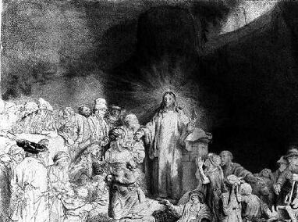
100 Gulden Print: Christ Preaching

Japan paper, washi, was particularly favored for wood (copper) printing by the Dutch Art Master because of its strength and softness of expression by the ink absorbed into the paper

