Traditional Industry
in Japan

Climate of Japan fostered and developed her own Traditional Industries in Japan. Typical examples are paper craft, Japan steel that has been used for Japanese sward.

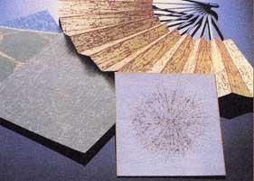
Washi (Handcraft Paper)


Japanese Sword

