Japan Steel
Engine Valve

Japanese made engine valves are widely used in USA and European car manufacturers, due to its high performances in high temperature environment.

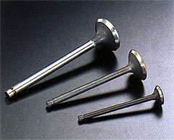
High performance Japan steel is used in many car manufacturers in USA and Europe as well as in Japan

