Japan Steel
Iron Sand

Japan has scant natural resources like oil, iron ore and etc. They found though it was small amount but quite high quality iron sand in various part of Japan. Iron sand is featured of its purity. A very small percentage of ingredients are seen in Iron Sand. It is almost pure oxide iron in crystal structure. They managed to extract high quality iron from iron sand and made extremely sharp and light Japanese sword with continued improvement by handcraft maestro.

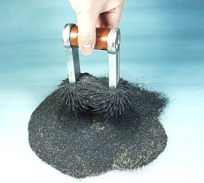
Iron Sand: Crystallized Oxide Iron

