Japan Steel
Henckels(German)
Kitchen Knife

Henckels kitchen knife is world famous of its sharp cutting performances. Blade part of knife is used Japan steel. Moreover, Henckels moved its main factory of kitchen knifes into Japan. Today whole manufacturing process of Kitchen Knife is done in Japan.

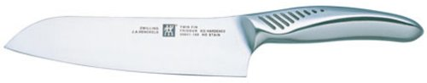
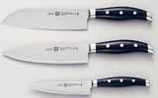
Today Henchels manufactures whole process of kitchen knife in Japan rather than importing blade steel from Japan
[Henckels Twin Cermax M66 Kitchen Knife]

