Japan Steel
Razor Blade

Men like sharp razor blade from the old time. Today, many manufacturers of razor use Japanese made razor blade and gaining satisfaction of the customer worldwide.

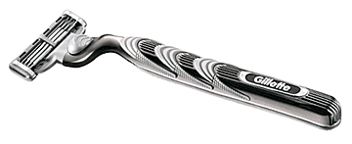
Japan supplies over 50% of razor blade of world demand

