Japan Steel
Tunnel Boring Machine

Euro Tunnel under the Dover strait has long been dream of the people. Cement like rock under the sea water had been preventing the work for decades. But, it had finally accomplished by Japanese TBM (Tunnel Boring Machine) in 1991. Break-through technique was sharp-hard cutting edge developed from Traditional Japan Steel.

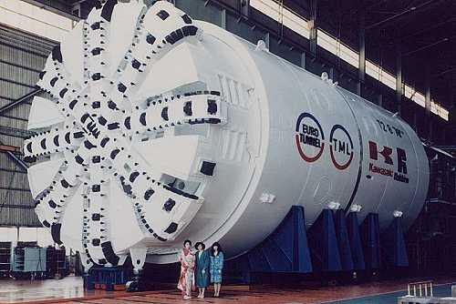
Giant TBM made by Kawasaki Heavy Industry Japan used for Euro-Tunnel Project

