Japan Steel
Turbine Blade

Japanese special metal alloy is used as turbine blades in modern high power jet engine fitted to the latest model of the aircraft, due to its high performances in high temperature environment where higher efficiency and power extracted from the smaller size engine.

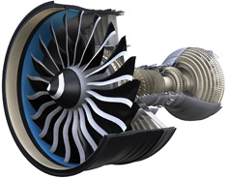
High performance special metal alloy that can be used in higher burning temperature of fuel is used as turbine blades in the latest model of aircraft jet engine

