Traditional Industry
in Japan
Japan Steel

Japan has scan natural resources like iron ore. But they managed to produce high quality steel that is soft, strong, light and extremely sharp. This skill is widely applied today to the many important part of modern industry.

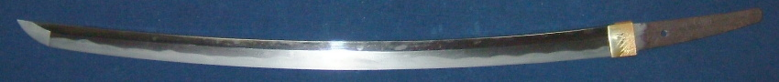
Japanese Sword

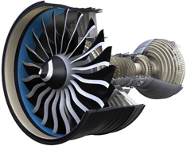
Turbine Blade of Latest High Power Jet Engine

