Shinkansen
New Technologies

- Long Rail: 1.5 km (25 m x 50 es.)
- No crossing (All exclusive & elevated track)
- Air tight Body (Stream Line Design)
- Anti-vibration by air spring
- No signal post but on Driver’s Seat
- Control all Traffic by CTC
- Anti collision keeps train 3 km or more
- Feed AC 25,000 V
- All Motored Car but calm room
- Half size Pantograph
- Emergency Stop SW: Every 250m
- Earthquake Detection: Stop Feeding

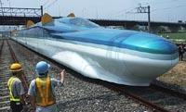
Latest Model: FASTECH360S
To be put into operation by 2011 at 360km/h

