Shinkansen Tech-1
Long Rail: 1.5km

Long Rail made no click noise

Conventional rail has length of approx. 25m/each, and connected with small gap that makes a click sound when car travel on the gap. Shinkansen uses extra long rail of 1.5 km, welded 50 conventional 25m-rail into one piece. And connection section uses sliding cut, but no rectangular gap. That reduced acoustic noise in the car tremendously.

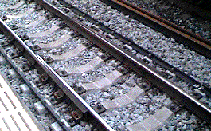
Inner side Rail
Outer side Rail
Joint Section of Long Rail

