Shinkansen Tech-3
All Motored Car

All Cars have Motor

It had been common in long distant passenger car to have been pulled by locomotives to have calmness in car. But it has big disadvantage of need the heavy duty railway track costs huge amount, and limit the cruise speed. Shinkansen puts motor on all cars and developed the extra low acoustic noise motor, so that it achieved the unprecedented high cruise speed and quietness in the car.

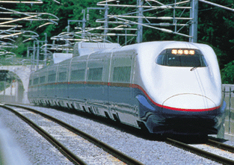
All Cars have Motor

