Shinkansen Tech-4
No Signal Post

Signals are on Driver’s Seat

Since it travels 300km/h, a driver can not see ordinal signals displayed on posts ahead, it is no use of building ordinal signal posts throughout the Shinkansen track. So, no signal post on track is built, but all signals are displayed on driver’s seat and CTC (Centralized Traffic Control System) at the control center.

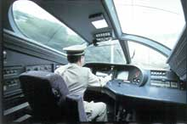
All Signals are displayed on Driver’s Seat
But no signal post throughout the track

