Shinkansen Tech-5
CTC
(Centralized Traffic control)

All Traffic is Controoled by CTC

Failsafe CTC system had been newly developed that control all traffic at control center that employ numbers of failsafe system in it, because once the mass transport, high speed train made accident, it shall be the real tragedy. Thanks to the CTC, it has proved safest car since its debut in 1964.

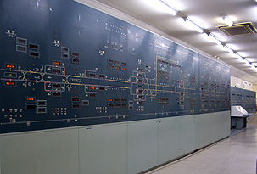
CTC controls all traffic at control center
Today, displays are replaced by computer monitor

