Shinkansen Tech-6
Air Tight Body

In Tunnels, air pressure kept normal

The tracks are made as straight and smooth. Due to Japanese geographical features, many tunnels are located throughout the tracks. To avoid the rapid air pressure changes when passing through tunnels, body is made air tight design similar to airplane. So that passenger can enjoy the uninterrupted comfortable journey all the way to the destination. Further, windows are double sealed securing good heat/acoustic insulation.

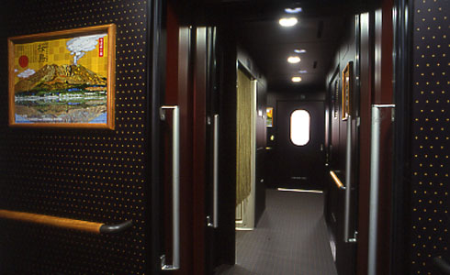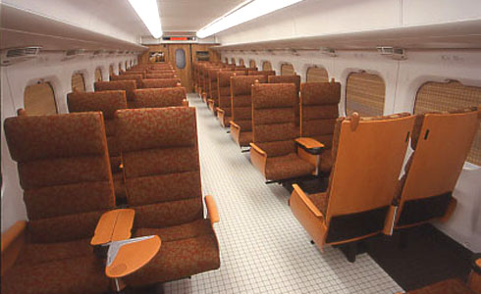
Interior of Passenger Car

