Shinkansen Tech-7
Streamline Design

More Environmental Friend

Aerospace design is used abundantly to maximize speed and minimize air cutting noise inside/outside. Long nose (16m), air flap break, half-size pantograph three layer reinforced windscreen and etc. are these technologies.

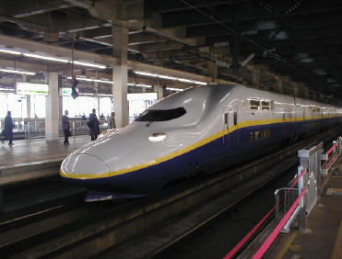
Aerospace designed long noise body reduce air cutting noise inside/outside

