Shinkansen Tech-8
Safety Measures

Safe Transport is First Priority

All elevated track in the city area. No crossing throughout the track. Every 250m along the railway track, emergency stop switch is installed. Anti-collision system keeps all traffic more than 3 km at any time. 48 earthquake detectors located that shut down the feed upon detected the earthquake.

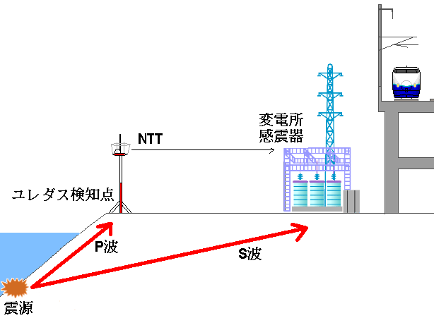
Epicenter
Earthquake Detector
Transformer Substation
P-wave
S-wave
Anti-Earthquake System of Shinkansen

