Shinkansen Tech-9
Feeding

AC 25,000V is fed

Conventional railway system is fed DC 1,500V. Shinkansen is fed AC 25,000V to maximize total energy efficiency. Only two pantographs are installed in one connected trains. Pantograph is designed in aero form to reduce the air friction and noise.

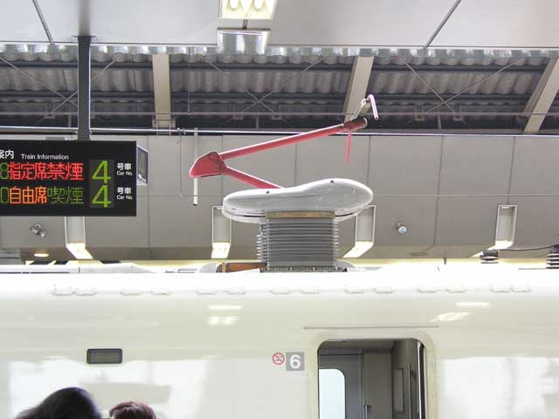
Single Arm Pantograph pushing up at 5kg

