Accident may Happen

90 Seconds Delay Killed 107 people

Edging sharp punctuality and extra dense traffic of Japanese Railway System is world famous. But, to our great regret, excess effort to keep the punctuality had led the tragic accident claiming 107 lives in April/’05 near Osaka. Driver drove the train above the safety speed to restore 90 seconds delay that is well within the tolerance in other countries.

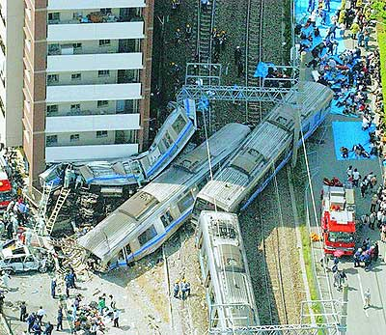
Tragic Accident in Apr/’06 near Osaka
was caused by catching up 90 seconds delay

