Railway System
in Japan

Japan has developed and maintains a highly efficient, accurate and safety railway network system throughout the country. The success of high speed train, Shinkansen in 1964 claimed the sparkling renaissance of railway transportation that considered outdated and recessing at the time, in all over the world. Today, it stretches 32,674 km, and carries 60 million peoples and 140 thousands tons of cargo each day. But its impeccable accuracy had unfortunately led to the recent tragic accident in May/’05 near Osaka.

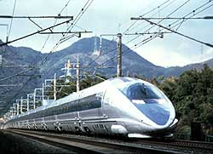
Shinkansen (Bullet Train: 300km/h)

