Energy Supply
in Japan

Japan has scant natural resources. To sustain our highly developed industry, a large amount of crude oil and other materials have to be imported flawlessly. Today, Japan importing 93.3% of energy sources from abroad. This extremely high percentage drives Japanese people makes hard work, every possible improvement, keep delivering high quality products in the global market.

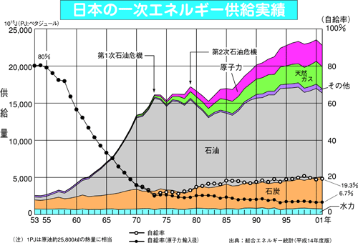
Domestic Supply
Peta Jour
Nuclear
Natural Gas
Crude Oil
Others
Coal
Hydraulic
1st
Oil Shock
2nd
Oil Shock
Domestic Supply %
Crude Oil
Energy Supply and its Domestic Rating

