Efficiency of
Energy Consumption
in Japan

Since Japan has to import majority of Energy sources from abroad, efficiency of energy consumption is ever our major concern. Strenuous effort has been kept one after another. Consequently energy efficiency of Japan has become the top among major industrial countries.
Energy Consumption of Major Industrial Countries
y Consumption of major industrial countries
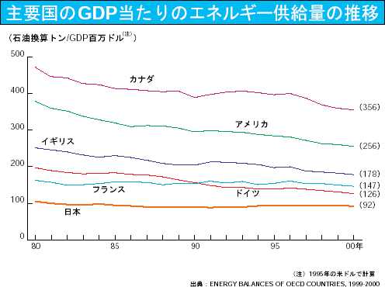
Unit: Crude Oil (Ton)/1M$
Canada
USA
UK
Japan
France
Germany

