Japan Import Oil
3,500,000 barrel/
Each day

Oil is number one energy source in Japan. And more than 90% of much needed oil is imported from abroad. 3,500,000 barrels of crude oil is imported each day from mainly Middle Eastern countries.

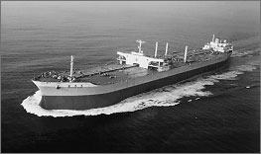
Oil Tanker: “Idemitsu Maru”
It carries 209,000 tons of crude oil
This amount is one day energy consumption in Japan

