Top Efficiency
In Energy Consumption

As Japan has scant natural resources, we always had to make strenuous effort to cut the fuel cost. This made Japan the top energy efficient county among the world. Demand of this tendency has ever been increasing due to the need of environmental preservation in order to reserve the blue shining planet for our offspring.

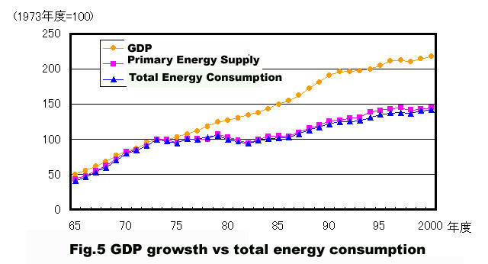
Despite the continued GDP growth, energy consumption is suppressed after the 1st oil shock in 1973

