Who Supply
Energy Resources
To Japan

Middle Eastern countries are always major supplier of Japan’s much needed energy resources. Percentage of crude oil imported from this area is ever high as above 80% except one decade of ’80 which coincides 1st and 2nd oil shock.

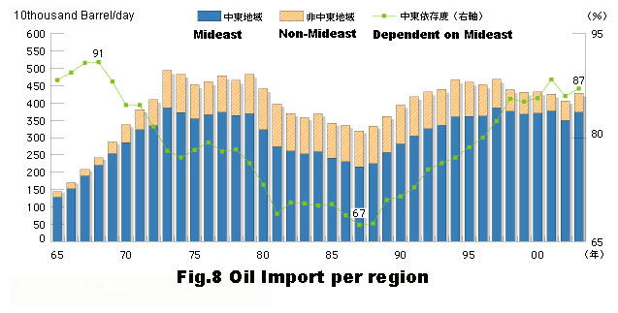
Middle Eastern countries are always major crude oil supplier to Japan

