Marriage/Population
in Japan

Marriage is always admiration for men and women, and certainly be one of the biggest event of one’s life. What is the contemporary marriage in Japan and what outcomes are expected in its trend and future.

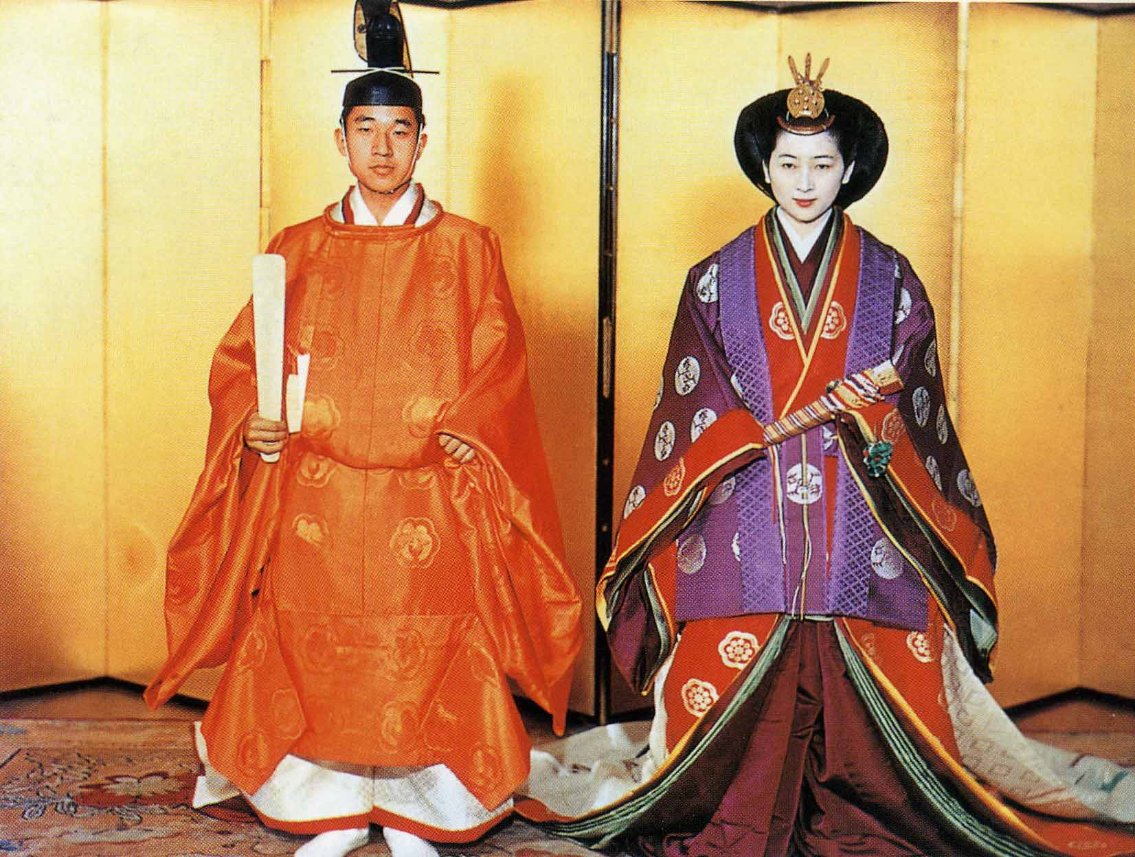
Formal attire of wedding worn on the occasion of the marriage ceremony of current Emperor Akihito to Masako, a daughter of former Japanese Ambassador to USA

