Population Shift
in Japan

It is the extremely shocking fact that the population of Japan would be cut half in next 100 years. Late marriage and fewer deliveries of married/un-married women make this death road solid ever in Japan. Every possible effort to curve the plague must be taken to save the country.

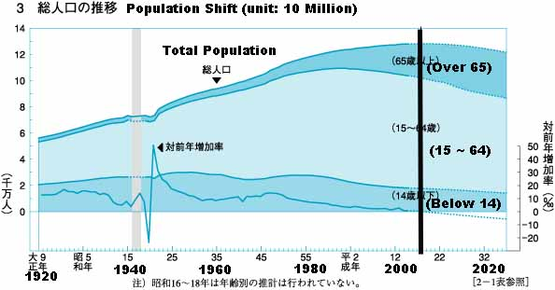
Current Population of Japan is approx. 138 million. This number will start decreasing in year 2006 and drops to half in next 100 years. This is one of the biggest problems we have in Japan.

