Wedding Ceremony
in Japan

Shintou style ceremony is still at large, say around 80% of all. More couples are doing in less costly and fancy one like Christian style although they are not Christian.

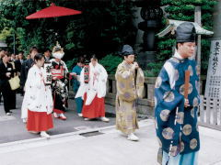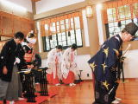
①Procession to the Shrine ②Bow in front of the shrine alter
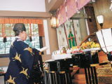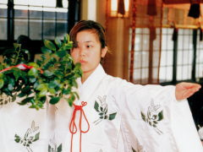
③Monk pledge the marriage proclamation ④A nun performs ritual in front Shintou altar
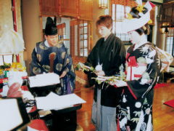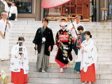
⑤A couple pledge marriage before the Shintou altar ⑥A couple returns home
One example of a process of Wedding ceremony in the Shintou Style

