Formal Attire
Juuni-Hitoe

Twelve-folded Kimono, Juuni-Hitoe in Japanese, is the formal attire for Japanese women in the ceremony. Today it is worn only in special cases such as princess’s wedding and of other noble person.

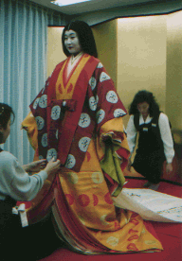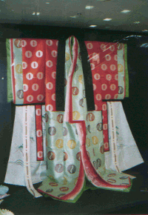
Juuni-Hitoe is worn by the special dressing helper

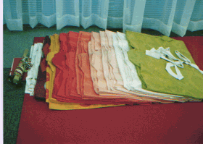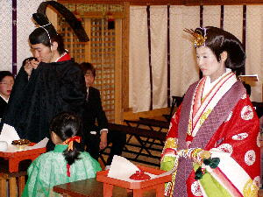
A set of Juuni-Hitoe A couple in their wedding ceremony in Juuni-Hitoe Attire

