Traditional Attire
Bunkin Takashimada

This hair-style is still common in Japanese wedding ceremony. The hair beautifully decorated, but usually it is covered by white cloth so called Tsuno-Kakushi (Horn Hide)

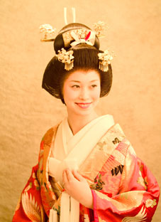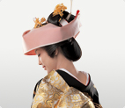
Bunkin Takashimada Hair Style Tsuno Kakushi on hair

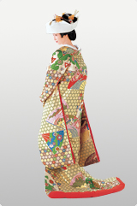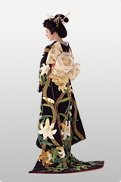
Kimono Style of wedding attire with Bunkin Takashimada Hair Style

