Wedding Kimono
Hand woven Silk ‘Uchikake’

“Uchikake”, hand woven silk wedding attire had been the treasure next to her life. Today, it is common to rent it instead of own the extremely expensive one for only one time use.

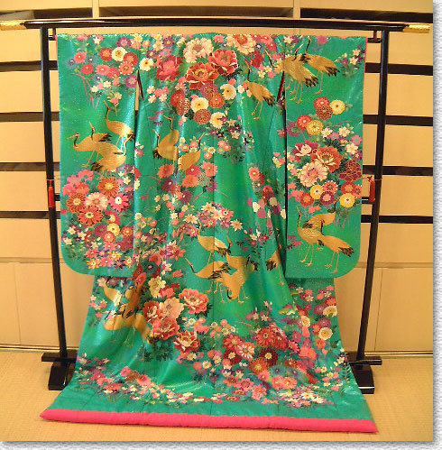

Hand woven silk wedding attire “Uchikake” or “Yuzen”

